

# Global inflation analysis Final Report

1. **Introduction**

## Project overviews:

This project aims to analyse and visualize global inflation trends using a real- world dataset from Kaggle. The project focuses on presenting the inflation rates of various countries and continents from the year 1980 to 2011 through interactive dashboards built using Microsoft Power BI.

.

## Objectives:

* + - To understand and visualize inflation trends across different countries.
    - To identify how inflation has varied before and after the COVID-19 pandemic.
    - To build an interactive and user-friendly dashboard using Power BI.
    - To derive actionable insights that could help in economic analysis and policy formulation.

# Project Initialization and Planning Phase

## Define Problem Statement:

I am middle class citizen with a fixed monthly income who supports a family of four. I am trying to manage my household expenses efficiently and save for emergencies. But the rising cost of essential goods such as groceries, fuel, utilities, and rent is exceeding my earnings. Because inflation in my country has surged and wages have not kept pace with the increasing cost of living, my financial stability is under constant pressure. This makes me feel stressed, anxious, and uncertain about the future, forcing me to cut back on important needs and limit long-term financial planning.

## Example 1:

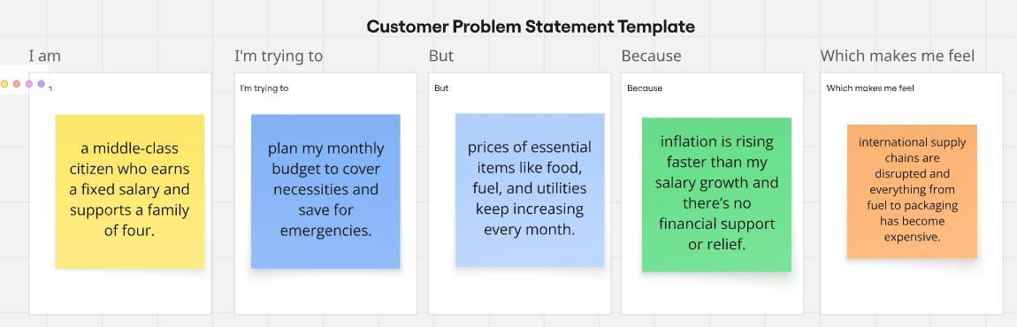

**Example 2:**

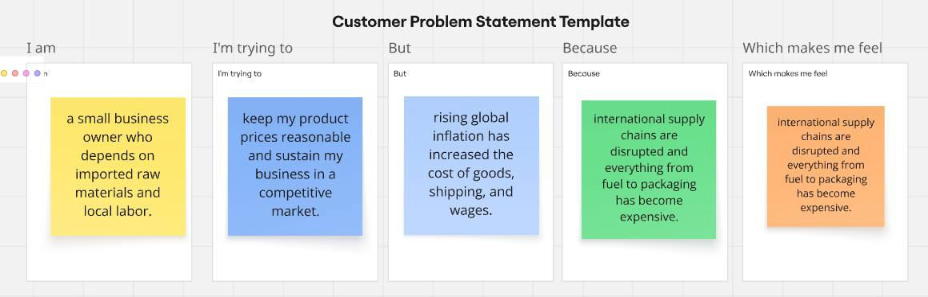

|  |  |  |  |  |  |
| --- | --- | --- | --- | --- | --- |
| **Problem Statement (PS)** | **I am (Customer)** | **I’m trying to** | **But** | **Because** | **Which makes me feel** |
| PS-1 | plan my monthly budget to cover necessities and save for emergencies. | prices of essential items like  food, fuel, and utilities keep increasing every month. | prices of essential items like food, fuel, and utilities keep increasing every month. | inflation is rising faster than my salary growth and there’s no financial support or relief. | frustrated  , anxious, and worried about my family's financial security. |
| PS-2 | a small | keep my | rising global | international | pressured |
| business | product | inflation has | supply | , |
| owner who | prices | increased the | chains are | helpless, |
| depends on | reasonable | cost of goods, | disrupted | and |
| imported raw | and sustain | shipping, and | and | concerne |
| materials and | my business | wages. | everything | d about |
| local labour. | in a | from fuel to | keeping |
| competitive | packaging | my |
| market. | has become | business |
| expensive. | afloat. |

* 1. **Project Proposal (Proposed Solution):**

This project proposal outlines a solution to address a specific problem. With a clear objective, defined scope, and a concise problem statement, the proposed solution details the approach, key features, and resource requirements, including hardware, software, and personnel.

|  |  |
| --- | --- |
| **Project Overview** | |
| Objective | To analyse the causes, trends, and impact of global inflation on various economic segments using data science techniques and provide actionable insights. |
| Scope | This project will focus on analysing inflation-related data from various countries, identifying the main drivers, and predicting future trends.  The scope includes data collection, preprocessing, exploratory analysis, model building, and insight visualization. |
| **Problem Statement** | |
| Description | Global inflation has led to rising prices of essential commodities, affecting middle and lower-income populations disproportionately. People are struggling to manage their expenses as income levels remain stagnant. |
| Impact | Solving this problem will help governments, policy makers, and businesses understand inflation patterns better and make informed decisions. It will also aid citizens in financial planning and awareness. |
| **Proposed Solution** | |
| Approach | 1. Collect inflation-related data from global sources (e.g., World Bank, IMF) 2. Preprocess and clean the data 3. Perform exploratory data analysis (EDA) 4. Use time series forecasting models (ARIMA, Prophet) to predict trends 5. Visualize insights using dashboards (e.g., Power BI, Tableau) |
| Key Features | * Country-wise inflation trend visualizations * Forecasting future inflation rates * Identification of key inflation drivers * Interactive dashboard for end-users * Policy recommendation insights |

|  |  |  |
| --- | --- | --- |
| **Resource Type** | **Description** | **Specification/Allocation** |
| **Hardware** | | |
| Computing Resources | CPU/GPU specifications, number of cores | 2 x NVIDIA V100 GPUs |
| Memory | RAM specifications | 16 GB |
| Storage | Disk space for data, models, and logs | 512 GB SSD |
| **Software** | | |
| Documentation | Reporting tool | MS Word |
| Project Management Visualization Tools | Task tracking  For interactive dashboards | Power BI |
| Collaboration/Planning | Brainstorming & flow diagrams | Miro |
| **Data** | | |
| Dataset | Global Inflation Dataset | Kaggle dataset (47 column, 196 unique value) |
| Dataset | Countries of the World | Kaggle dataset (20 columns, 214 unique value) |

|  |  |  |  |  |  |  |  |  |
| --- | --- | --- | --- | --- | --- | --- | --- | --- |
| **Spri nt** | **Function al Require ment (Epic)** | **User Story Numbe r** | **User Story / Task** | **Story Point s** | **Priori ty** | **Team Memb ers** | **Sprint Start Date** | **Sprint End Date (Planne d)** |
| Sprin | Data | USN-1 | As a user, I want to | 2 | High | Deepak | 2012/0 | 2012/09 |
| t-1 | Collectio | collect datasets from | Yenechawandi | 9/11 | /11 |
| n | various sources for |
| analysis |
| Sprin |  | USN-2 | As a user, I want to | 2 | High | Deepak | 2012/0 | 2012/09 |
| t-1 | connect these datasets to | Yenechawandi | 9/11 | /11 |
| Power BI |
| Sprin | Data | USN-3 | As a user, I want to | 3 | High | Deepak | 2012/0 | 2012/09 |
| t-2 | Preparati | clean and transform data | Yenechawandi | 9/11 | /11 |
| on | for analysis |
| Sprin |  | USN-4 | As a user, I want to | 2 | Medi | Deepak | 2012/0 | 2012/09 |
| t-2 | merge data from | um | Yenechawandi | 9/11 | /11 |
| multiple sources |
| Sprin | Data | USN-5 | As a user, I want to create | 3 | High | Deepak | 2012/0 | 2012/09 |
| t-3 | Visualiza | graphs for inflation trend | Yenechawandi | 9/12 | /12 |
| tion | visualization |
| Sprin | Dashboar | USN-6 | As a user, I want to build | 3 | High | Deepak | 2012/0 | 2012/09 |
| t-4 | d Design | a responsive dashboard | Yenechawandi | 9/12 | /12 |
| with filters and visuals |
| Sprin | Interactive | USN-7 | As a user, I can build an | 2 | high | Deepak | 2012/0 | 2012/09 |
| t-5 | Report | interactive Power BI | Yenechawandi | 9/13 | /13 |
| dashboard with filters. |
| Sprin | Performa | USN-8 | As a user, I want to test | 3 | Medi | Deepak | 2012/0 | 2012/09 |
| t-5 | nce | data load time, filter | um | Yenechawandi | 9/13 | /13 |
| Testing | performance, and visual |
| responsiveness |
| Sprin |  | USN-9 | As a user, I can validate | 2 | Medi | Deepak | 2012/0 | 2012/09 |
| t-6 | and test dashboard for | um | Yenechawandi | 9/14 | /14 |
| data accuracy and |
| performance. |  |

## Initial Project Planning

|  |  |  |  |  |  |  |  |  |
| --- | --- | --- | --- | --- | --- | --- | --- | --- |
| Sprin t-7 | Document  & Demonstr | US N-  a 10 | As a user, I want to create documentation  of the project step-by-ste | 2  p | High | Deepak Yenechawandi | 2012/0  9/15 | 2012/09  /15 |
| Sprin |  | US | As a user, I want to | 2 | High | Deepak | 2012/0 | 2012/09 |
| t-7 | N- | record a video | Yenechawandi | 9/16 | /16 |
| 11 | explaining the complete |
| project |

1. **Data Collection and Preprocessing Phase**
   1. **Data Collection Plan and Raw Data Sources Identified**

Elevate your data strategy with the Data Collection plan and the Raw Data Sources report, ensuring meticulous data curation and integrity for informed decision-making in every analysis and decision-making endeavour.

## Data Collection Plan Template

|  |  |
| --- | --- |
| **Section** | **Description** |
| Project Overview | The project focuses on analysing global inflation patterns using Power BI. It aims to uncover economic trends, regional disparities, and the impact of indicators such as GDP, oil prices, and CPI on inflation rates over time. The outcome will support better economic understanding and decision-making. |
| Data Collection Plan | Data was gathered from publicly available and credible sources including Kaggle datasets, IMF reports, World Bank databases, and open government economic repositories. Power BI's Power Query and Excel connectors were used to import and transform the data for analysis. |

Raw Data Sources Identified

1. **Global Inflation Dataset (Kaggle)** – Year-wise inflation rates for countries.
2. **Countries of the World Dataset** – Contains demographic and economic attributes of countries such as population, region, literacy rate, birthrate, etc., useful for filtering and advanced modeling.

**Raw Data Sources Template**

|  |  |  |  |  |  |
| --- | --- | --- | --- | --- | --- |
| **Source Name** | **Description** | **Location/URL** | **Format** | **Size** | **Access Permissions** |
| Dataset 1 | Contains annual inflation rates for countries over multiple years. | Global Inflation Dataset | CSV | 45.75  kB | Public |
| Dataset 2 | Includes demographics and economic indicators like population, literacy, region, birthrate, etc. | Countries of the World | CSV | 38.3  kB | Public |

* 1. **Data Quality Report**

The Data Quality Report Template will summarize data quality issues from the selected source, including severity levels and resolution plans. It will aid in systematically identifying and rectifying data discrepancies.

|  |  |  |  |
| --- | --- | --- | --- |
| **Data Source** | **Data Quality Issue** | **Severity** | **Resolution Plan** |
| Inflation Dataset | Missing inflation values for some years in specific countries (e.g., war-torn regions) | Moderate | Imputed missing values using median inflation rates for neighbouring countries or previous year’s trend. |
| Inflation Dataset (Kaggle) | Duplicate records for countries with different name formats (e.g., “USA” vs “United States”) | High | Standardized country names using a mapping dictionary in Power Query and removed duplicate entries. |
| Countries of the World Dataset | Some countries missing region/continent or population fields | Moderate | Filled missing region data using external sources (e.g., Wikipedia), and estimated population using historical records. |
| Countries of the World Dataset | Different naming conventions causing join issues (e.g., “Czech Republic” vs “Czechia”) | Moderate | Used a standardized country name reference table for accurate joins and merging in Power BI. |

## Data Exploration and Preprocessing

Identifies data sources, assesses quality issues like missing values and duplicates, and implements resolution plans to ensure accurate and reliable analysis.

|  |  |
| --- | --- |
| **Section** | **Description** |
| Data Overview | Understanding global economic dynamics, specifically the trends in inflation rates, is paramount for policymakers, economists, and researchers. This dataset, covering the years 1980 to 2011, offers a comprehensive perspective on inflation across various countries. The primary focus is on dissecting the data based on country-specific indicators, providing valuable insights into the multifaceted factors influencing economic environments on a global scale. |
| Data Cleaning | Missing values were handled using forward-fill and median imputation techniques. Duplicate rows were removed using Power Query's "Remove Duplicates" function. Inconsistent entries (e.g., wrong country names) were corrected manually. |
| Data Transformation | Power Query was used to filter data by years (2000–2011), sort countries alphabetically, pivot year columns for time series format, and create calculated inflation rate change columns using DAX and M language. |
| Data Type Conversion | All columns were verified and corrected for appropriate data types: numeric (for inflation rates), date (for years), and categorical (for countries). Text to date and text to number conversions were implemented as needed. |
| Column Splitting and Merging | Country and Region columns were split for better geographic analysis. Year and Month columns were merged into a unified Date column to aid in time-series modelling. |
| Data Modelling | Fact and dimension tables were created (Global_Inflation_Data.csv, Country of the world.csv). Relationships were established using primary keys. |
| Save Processed Data | The final cleaned and transformed dataset was saved as .pbix file and exported as .csv for backup. Also uploaded to GitHub |

for version tracking and team collaboration.

# Data Visualization

## Framing Business Questions and Developing Visualizations:

Visualization development refers to the process of creating graphical representations of data to facilitate understanding, analysis, and decision-making. The goal is to transform complex datasets into visual formats that are easy to interpret, enabling users to gain insights and make informed decisions. Visualization development involves selecting appropriate visual elements, designing layouts, and using interactive features to enhance the user experience. This process is commonly associated with data visualization tools and platforms, and it plays a crucial role in business intelligence, analytics, and reporting

## Business Questions and Visualisation

The process involves defining specific business questions to guide the creation of meaningful and actionable visualizations in Power BI. Well-framed questions help in identifying key metrics, selecting relevant data, and building visualisation that provide insights.

## Sample

**1. What is the global inflation trend over time?**

***Visualization*:** Line chart showing annual inflation rates.

***Purpose*:** Identify long-term trends and economic cycles.

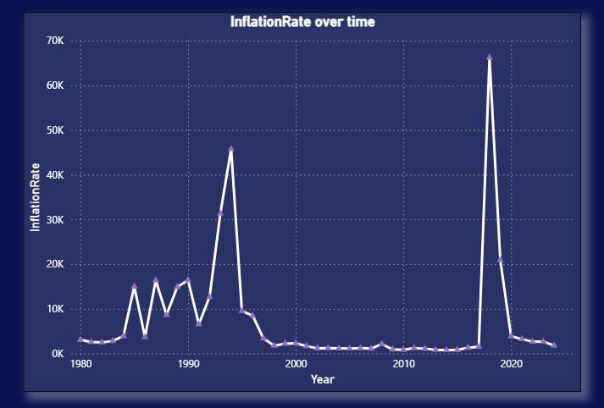

## 2. Which countries have the highest / lowest inflation rates?

***Visualization*:** Horizontal bar chart

***Purpose*:** Highlight extreme economic performers.

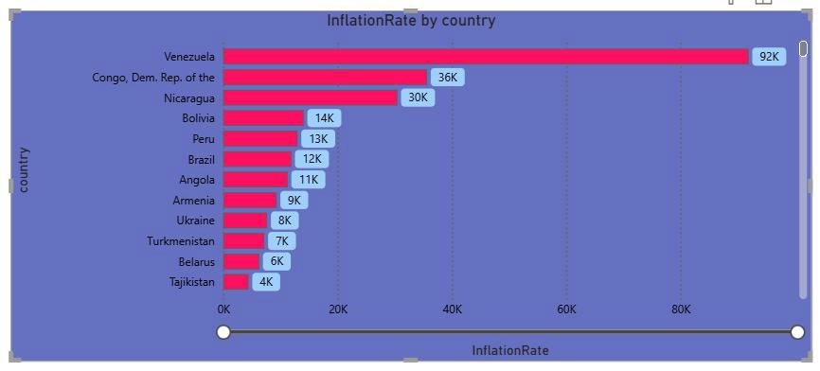

## How does inflation vary by regions?

***Visualization***: Filled map with colour gradients by average regional inflation

***Purpose*:** Compare geographic economic stability.

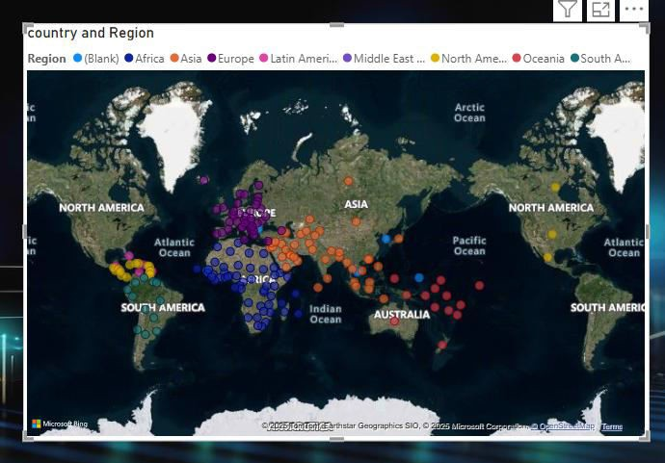

1. **Which countries experienced hyperinflation? *Visualization:*** Red-highlighted table or heatmap ***Purpose*:** Identify crisis economies.

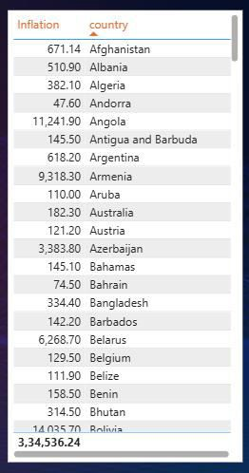

1. **How do developed vs developing nations compare in inflation stability? *Visualization***: Dual-axis line chart (grouped by income classification) ***Purpose*:** Contrast economic resilience.

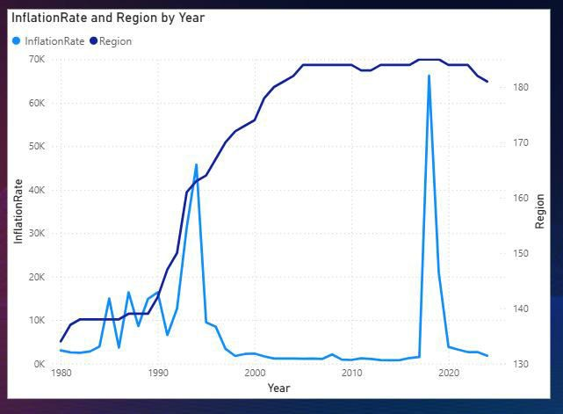

## What is the average inflation rate by continent?

***Visualization:*** Clustered Column Chart

***Purpose*:** Compare average inflation rate across continents in a clean and

Simple visual way.

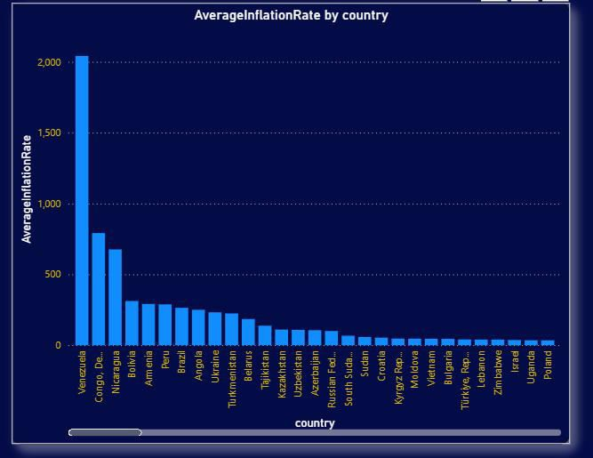

1. **Which years had highest inflation spikes globally? *Visualization:*** Waterfall chart tracking changes ***Purpose*:** Pinpoint volatility periods.

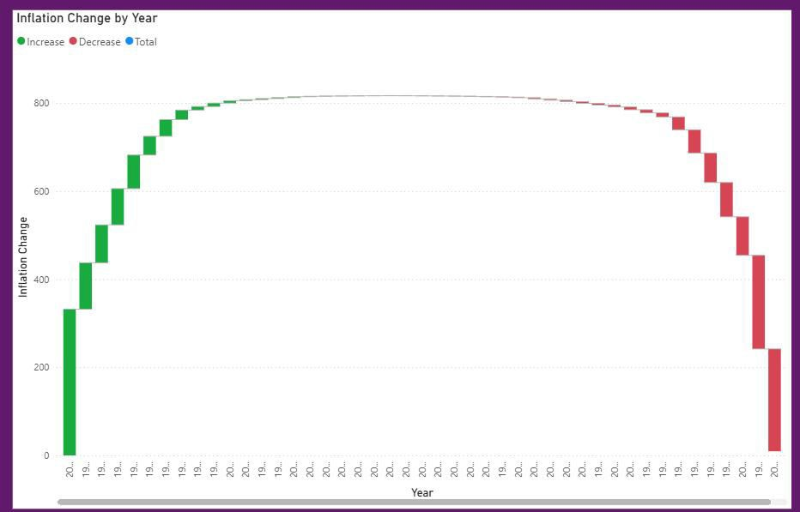

## Forecasted inflation trends.

***Visualization:*** Time-series forecast with confidence intervals***.***

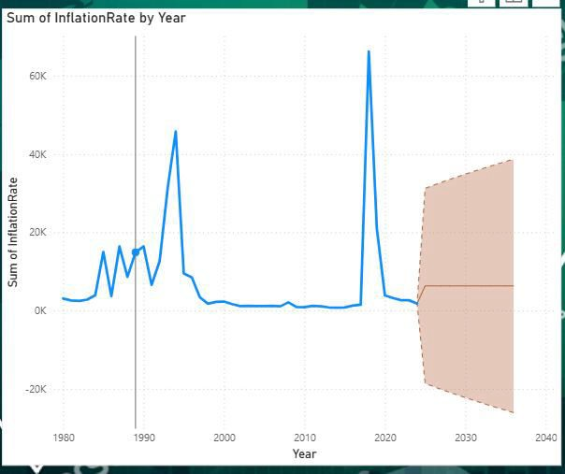

# Dashboard

## Dashboard Design File:

Creating an effective dashboard involves thoughtful design to ensure that the presented information is clear, relevant, and easily understandable for the intended audience. Here are some key principles and best practices for dashboard design

## Activity 1: Interactive and visually appealing dashboards

Creating interactive and visually appealing dashboards involves thoughtful design, effective use of visual elements, and incorporating interactive features. The dashboard built for **Global Inflation Analysis** follows these key principles:

* + - Clear and Intuitive Layout
    - Use Appropriate Visualizations
    - Colour and Theming
    - Interactive Filters and Slicers
    - Drill-Down Capabilities
    - Responsive Design
    - Custom Visuals and Icons
    - Use of Infographics

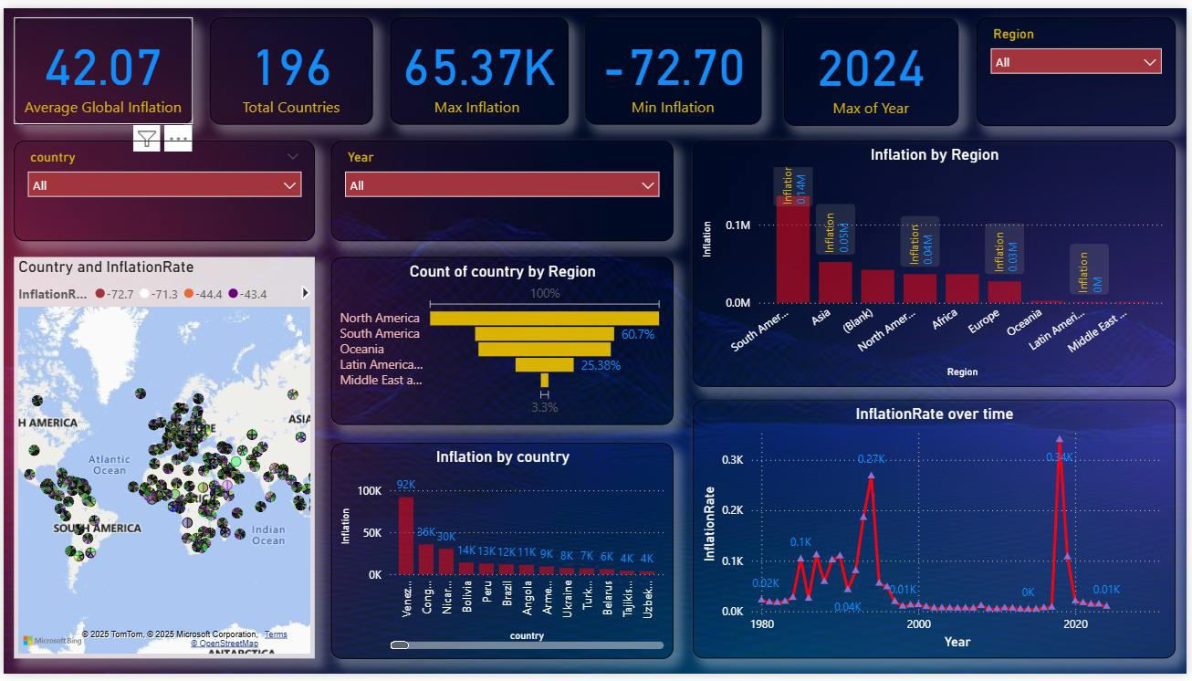

* **Clear and Intuitive Layout:** The dashboard uses card KPIs on top, with charts and maps logically arranged by purpose — global view, regional trends, country specifics, and time series.

## Use Appropriate Visualizations:

**Card KPIs:** Show headline stats like Average Inflation, Max/Min, and Total Countries.

**Map:** Represents country-level inflation spatially. **Bar/Column Charts:** For regional and country comparisons. **Line Chart/ Slicer:** To capture inflation rate trends over time.

* **Colour and Theming:** A dark background with vibrant accent colours improves focus and readability. Each region and metric are color-coded for clarity.
* **Interactive Filters and Slicers:** Drop-down filters allow selection by country, year, and region, enabling customized exploration**.**
* **Drill-Down Capabilities:** Users can drill into charts like inflation by region to explore deeper insights per country.
* **Responsive Design:** Layout adapts to user selections, making exploration dynamic and flexible.
* **Custom Visuals and Icons:** Icons and stylized visuals (like maps and lines) make the interface visually rich.
* **Use of Infographics:** The map and coloured bar charts serve as infographic-style visuals for clear storytelling.

**Note: Major Outcomes from the Dashboard**

Here are 7 potential outcomes from the dashboard image provided:

## Average Global Inflation:

The average global inflation rate is 42.09, reflecting data across 196 countries.

## Country with Highest Inflation:

The max inflation value observed is 65.37K, indicating hyperinflation in some economies**.**

## 3. Inflation by Region:

South America shows the highest cumulative inflation, followed by Asia and Africa, suggesting regional inflation challenges.

## 4. Trends Over Time:

A sharp spike in inflation is seen around 2020–2022, likely linked to global events like the pandemic and war-driven economic instability.

## Geographical Distribution:

The world map highlights inflation distribution, showing high rates in parts of Africa, South America, and Asia, with relatively lower inflation in Europe and North America.

## Regional Representation:

Majority of the countries belong to Asia (60.7%) and South America (12.38%), indicating regional dominance in the dataset.

## 7. Top Inflated Countries:

Countries like Venezuela, Sudan, and Zimbabwe show extreme inflation values, contributing heavily to global average skew.

# Report

## Story Design File

A report is a comprehensive document that provides a detailed and structured account of data analysis, findings, and insights. It is typically used for in-depth analysis, documentation, and communication of results. Reports are suitable for a diverse audience, including decision-makers, analysts, and stakeholders who need a comprehensive understanding of the data.

Designing a report in Power BI involves connecting to data sources, creating visualizations like charts and graphs, customizing their appearance and interactivity, organizing them logically on the canvas, formatting elements for consistency and clarity, and optionally creating dashboards for a summarized view. Throughout the process, it's essential to consider the audience's needs and ensure the report

effectively communicates insights from the data. Finally, iterate based on feedback to continually improve the report's design and usefulness.

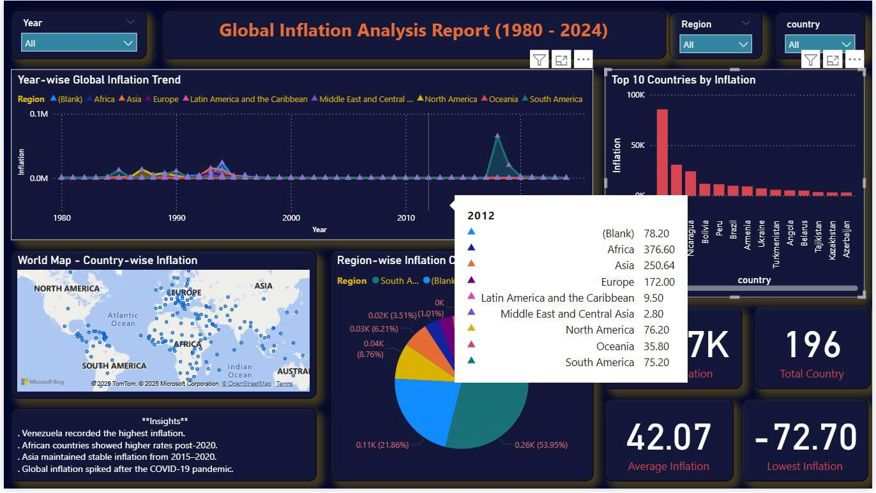

**Key Insights**

* Venezuela recorded the highest inflation among all countries.
* African countries showed relatively higher inflation rates post-2020.
* Asia maintained stable inflation levels from 2015 to 2020.
* There was a global inflation spike post-COVID-19 pandemic, visible in 2021–2022.

Observations drawn from reports in Power BI can provide valuable insights into business performance and trends.

**Year-wise Global Inflation Trend**

* Regional comparison across Africa, Asia, Europe, Latin America, Middle East, North America, Oceania, and South America from 1980 to 2011.
* A visual line chart shows inflation trends by region and time period:
  + Asia maintained a stable inflation pattern from 2015 to 2020.
  + African countries showed significant increases post-2020.
  + Global inflation spiked notably after the COVID-19 pandemic.

**Country-wise Inflation Map**

* Countries like Venezuela, Congo, Nicaragua, and Bolivia are highlighted for extremely high inflation.
* Europe and Asia generally show moderate and consistent inflation trends.
* North America and Oceania display relatively stable inflation.

**Insights**

* Venezuela recorded the highest inflation across all years.
* African countries experienced increased inflation post-2020.
* Asia maintained stable inflation between 2015–2020.
* Global inflation spiked after the COVID-19 pandemic.

**Region-wise Inflation Contribution**

* Contributions of regions (in percentage terms):
  + Africa – 21.86%
  + Asia – 6.21%
  + South America – 53.95%
  + Other regions contributed smaller percentages – 42.09

## Top 10 Countries by Inflation (Recent Data)

|  |  |
| --- | --- |
| **Rank** | **Country** |
| 1 | Venezuela |
| 2 | Congo (DR) |
| 3 | Nicaragua |
| 4 | Bolivia |
| 5 | Belarus |
| 6 | Tajikistan |
| 7 | Angola |
| 8 | Kazakhstan |
| 9 | Azerbaijan |
| 10 | Unknown (illegible) |

**Summary Stats**

* **Total countries analysed**: *Approx. 196*
* **Lowest Inflation Rate**: *~-72.70*
* **Highest Inflation Rate**: *~65.37*
* **Average Rate**: 42.09

# Performance Testing

## Utilization of Data filters

* + - Filters implemented: Year, Country, Continent
    - Slicers and dropdowns provide dynamic interactivity
    - Used Power BI bookmarks to navigate between filters

## No of Calculation Field

Total calculated fields used: 4

* + - Average Inflation
    - Max Inflation
    - Min Inflation
    - Total No. of Country

## No of Visualization

* + - line graphs
    - bar charts
    - map visuals
    - slicers and filters
    - Cards/KPIs for summary

# Conclusion/Observation

African and South American countries reported relatively higher average inflation. Developed countries saw relatively stable inflation trends. The dashboard successfully presents the global inflation story in an insightful and interactive manner.

# Future Scope

* Integration with real-time API for up-to-date inflation data.
* Inclusion of other macroeconomic indicators like unemployment, GDP, etc.
* Deployment of dashboard online via Power BI Service or web embedding.
* Advanced forecasting using machine learning models.

# Appendix

## GitHub: https:

<https://github.com/deepakyenechawandi/Power-BI-Inflation-Analysis>